Implementation of bredth frist search algorthium

from queue import Queue

graph = {0: [1, 3], 1: [0, 2, 3], 2: [4, 1, 5], 3: [4, 0, 1], 4: [2, 3, 5], 5: [4, 2], 6: []}

print("The adjacency List representing the graph is:")

print(graph)

def bfs(graph, source):

Q = Queue()

visited_vertices = set()

Q.put(source)

visited_vertices.update({0})

while not Q.empty():

vertex = Q.get()

print(vertex, end="-->")

for u in graph[vertex]:

if u not in visited_vertices:

Q.put(u)

visited_vertices.update({u})

print("BFS traversal of graph with source 0 is:")

bfs(graph, 0)

out put:- 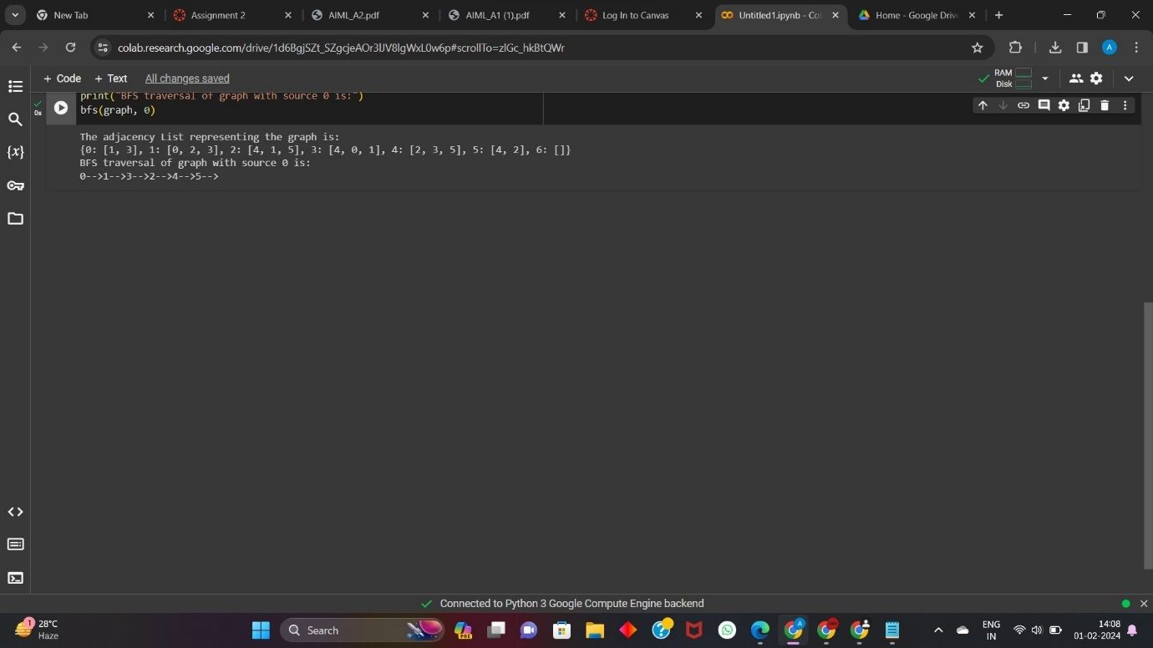

implementation depath frist search algorthium

graph1 = {

'A' : ['B','S'],

'B' : ['A'],

'C' : ['D','E','F','S'],

'D' : ['C'],

'E' : ['C','H'],

'F' : ['C','G'],

'G' : ['F','S'],

'H' : ['E','G'],

'S' : ['A','C','G']

}

def dfs(graph, node, visited):

if node not in visited:

visited.append(node)

for k in graph[node]:

dfs(graph,k, visited)

return visited

visited = dfs(graph1,'D', [])

print(visited)

OUT PUT:-

